SEMINAR

SERIES

**北京大学力工学院**

**航空航天工程系**

湍流与复杂系统国家重点实验室



|  |
| --- |
| **Kinetics of Oxidation of Sustainable Aviation Fuels** |

**Philippe Dagaut**

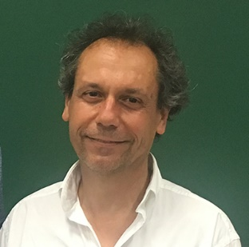

**French National Center for Scientific Research (CNRS) France**

**Abstract**

While there is growing importance of electric-powered ground transportation, combustion in aero gas turbines will remain important for years. Today, energy used worldwide mainly comes from fossil fuels. But, since the end of the 20th century, alternative energy resources have increasingly been used for guaranteeing security of supply and for mitigating global warming and air pollution. In the recent years, research activities on synthetic and bio-derived jet fuels (SAF) have increased significantly in order to reduce dependence of air transportation on oil (petroleum). In our recent works, it was intended to provide (i) kinetic data for SAF oxidation and (ii) a representative combustion model. The kinetics of oxidation of substitute jet fuels were studied in a JSR and simulated using detailed chemistry.

**Brief Biography**

P. Dagaut received his PhD in 1986. He is CNRS Research Director (Orleans, France) and Guest-Professor at Shanghai Jiao Tong University (2024-2027). He is past-President of the Combustion Institute (2020-2024). He has been Editor of Combustion and Flame and of the Proceedings of the Combustion Institute. He was awarded the A. Egerton Gold Medal, the Combustion Institute (2016), the CNRS Silver Medal (2016), and The International Prize for distinguished contributions to the international and Japanese combustion research community from the Combustion Society of Japan (2023). He has been Guest-Professor at the USTC, Hefei, (2013-2016). He published more than 350 peer reviewed papers with a h-index of 77 (Scopus).

**时间：2025年7月7日（周一）下午 14:00－15:00**

**地点：北京大学 新奥工学大楼 3048会议室**

**欢迎校内外师生光临！** 联系人：赵皓 18560647175